# DS lab 01 tasks

Name: Hamza Atif

Roll no: 24K-0594

TASK 01:

#include<iostream>

#include<string>

using namespace std;

class BankAccount{

    private:

    double balance;

    public:

    BankAccount(){

        balance = 0;

    }

    BankAccount(double initial) : balance(initial) {};

    BankAccount(const BankAccount &other){

        balance = other.balance;

    }

    void withdrawMoney(double amount){

        if(amount > balance){

            cout << "Insufficent balance! " << endl;

        }

        else{

            balance = balance - amount;

        }

    }

    void getBalance(){

        cout << "Balance: " << balance << endl;

    }

};

int main(){

    BankAccount account1;

    account1.getBalance();

    cout << endl;

    BankAccount account2(1000.0);

    account2.getBalance();

    cout << endl;

    BankAccount account3(account2);

    account3.getBalance();

    account3.withdrawMoney(200);

    account3.getBalance();

}

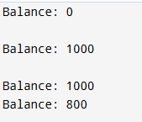

TASK 02

#include<iostream>

#include<string>

#include<cstring>

using namespace std;

class Exam{

    private:

    char *studentName;

    char *date;

    int marks;

    public:

    Exam(char *name , char* Date , int Marks) : marks(Marks) {

        studentName = new char[strlen(name)+1];

        date = new char[strlen(Date)+1];

        strcpy(studentName , name);

        strcpy(date , Date);

    }

    void setAttributes(char *name , char *Date , int Marks){

        marks = Marks;

        strcpy(studentName , name);

        strcpy(date , Date);

    }

    void display(){

        cout << "Name: " << studentName << endl;

        cout << "Date: " << date << endl;

        cout << "Marks: " << marks << endl;

    }

    ~Exam(){

        delete[] studentName;

        delete[] date;

    }

};

int main(){

    Exam exam("Hamza" , "25-8-2025" , 88);

    exam.display();

    cout << endl;

    exam.setAttributes("Hamza" , "25-8-2025" , 90);

    cout << endl;

    exam.display();

    Exam exam1 = exam;

    cout << endl;

    exam1.display();

    return 0;

}

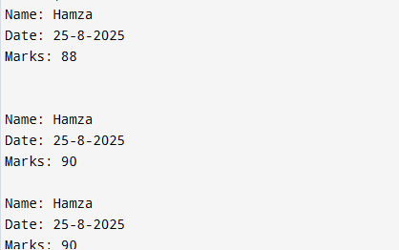

TASK 03:

#include<iostream>

#include<string>

#include<cstring>

using namespace std;

class Box{

    private:

    int *value;

    public:

    Box(int Value){

        value = new int(Value);

    }

    Box(const Box &other){

        value = new int(*other.value);

    }

    Box& operator=(const Box& other)

    {

        if(this != &other){

            delete value;

            value = new int(*other.value);

        }

        return *this;

    }

    void getValue(){

        cout << *value;

    }

    void changeValue(int num){

        *value = num;

    }

    ~Box(){

        delete value;

    }

};

int main(){

    Box box1(100);

    box1.getValue();

    cout << endl;

    Box box2 = box1;

    box2.getValue();

    cout << endl;

    box2.changeValue(90);

    box2.getValue();

    return 0;

}

